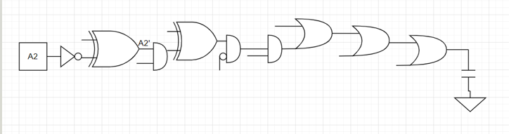

32

r

q

p

n

m

z

y

x

1

$C_{out}=32$ $C_{in}=1$

parasitic delay: $p_{XOR}=p_{AND}=3$

logic effort:

o

m

k

i

g

d

n

l

j

h

f

e

c

b

a

$C_{out}=32$ $C_{in}=1$

parasitic delay: $p_{XOR}=4$; $p_{NAND}=2$*; $p_{NOR}=2$*

logic effort: $g_{XOR}=4$ $g_{NAND}=1.4$ $g_{NOR}=1.6$

G = 1\*4\*1.4\*1\*4\*1.4\*1\*1.4\*1\*1.6\*1\*1.6\*1\*1.6\*1=179.83

B=1

H = 32/1 = 32

Path effort F = GHB = 175.58\*32\*1 =5754.59

Stage effort: $f^{*}= \sqrt[15]{F}$ 1.78

Min delay = $15×f^{*}+\left(1+4+2+1+4+2+1+2+1+2+1+2+1+2+1\right)=53.67$

$$o=1*\frac{32}{1.778}=18$$

$$n=\frac{5}{3}*\frac{18}{1.778}=16.87$$

$$m=1*\frac{16.87}{1.778}=9.49$$

$$l=\frac{5}{3}*\frac{9.49}{1.778}=8.9$$

$$k=1*\frac{8.9}{1.778}=5$$

$$j=\frac{5}{3}*\frac{5}{1.778}=4.69$$

$$i=1*\frac{4.69}{1.778}=2.64$$

$$h=\frac{4}{3}*\frac{2.64}{1.778}=1.98$$

$$g=1*\frac{1.98}{1..778}=1.11$$

$$f=\frac{4}{3}*\frac{1.11}{1.778}=0.83$$

$$e=4*\frac{0.83}{1.778}=1.88$$

$$d=1*\frac{1.88}{1.778}=1.05$$

$$c=\frac{4}{3}*\frac{1.05}{1.778}=0.79$$

$$b=4*\frac{0.79}{1.778}=1.78$$

$$a=1*\frac{1.78}{1.778}=1$$

Ctot = 76.01+32 = 183.02

E =